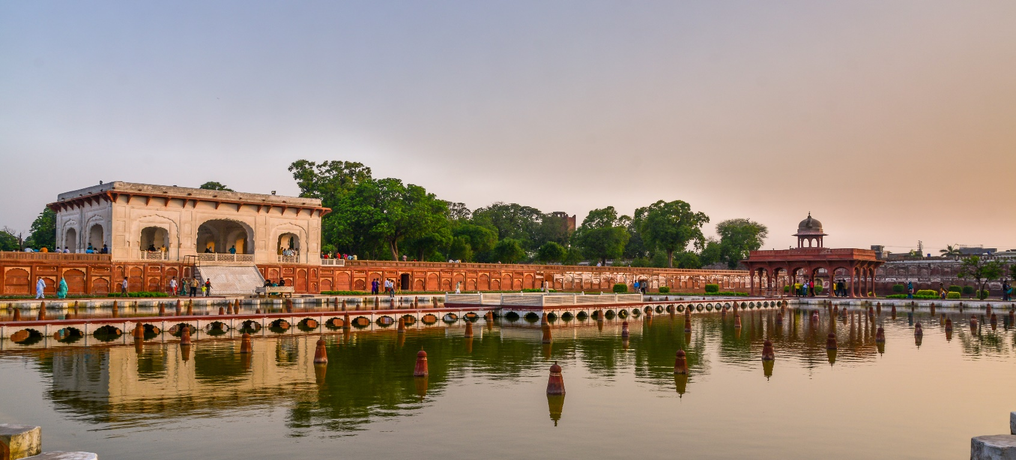

**SHALIMAR GARDENS**

**A Timeless Wonder of Mughal Architecture**

The Shalimar Gardens, located in the heart of Lahore, stand as a testament to the grandeur and artistry of the Mughal Empire. Constructed in 1642 by Emperor Shah Jahan, the gardens reflect the opulence and architectural genius of their era. Designed as a Persian-style paradise garden, the Shalimar Gardens showcase a symphony of flowing water, meticulously laid out terraces, and lush greenery. The blend of symmetry, geometry, and aesthetic appeal creates a tranquil oasis that has captivated visitors for centuries. Declared a UNESCO World Heritage Site, this masterpiece remains an enduring symbol of Mughal legacy and a must-visit destination for history and nature enthusiasts alike.

# The Enchanting Terraces of the Shalimar

# Gardens

One of the most remarkable features of the Shalimar Gardens is its

meticulously structured three-terrace layout. Each terrace is uniquely designed, symbolizing a step toward spiritual elevation. The uppermost terrace, known as Farah Baksh or "Bestower of Pleasure," is adorned with stunning pavilions and fountains, offering an idyllic ambiance. The middle terrace, Faiz Baksh or "Bestower of Goodness," is a lush expanse of greenery interspersed with marble-lined water channels. The lowest terrace, Hayat Baksh or "Bestower of Life," greets visitors with its picturesque pathways and cascading fountains. Together, these terraces create an atmosphere of serenity and grandeur, making the Shalimar Gardens an architectural marvel that blends functionality with breathtaking beauty.

**The Artistry of Waterworks and Fountains**

The Shalimar Gardens are celebrated for their sophisticated hydraulic engineering, a marvel of Mughal ingenuity. The gardens feature over 400 meticulously placed fountains, powered by an intricate network of water channels, tanks, and reservoirs. These fountains not only serve a functional purpose by cooling the environment but also create a mesmerizing visual and auditory experience for visitors. The soothing sound of water cascading through marble channels, combined with the gardens’ symmetrical layout, evokes a sense of tranquility. The integration of water with the surrounding greenery and Mughal architecture highlights the importance of harmony in nature and art, offering a unique glimpse into the luxurious lifestyle of the Mughal rulers.

**A Cultural and Historical Legacy**

Beyond its stunning architecture and lush landscapes, the Shalimar Gardens hold immense cultural and historical significance. These gardens served as a royal retreat, where emperors hosted grand festivities, diplomatic gatherings, and moments of leisure. Over time, the Shalimar Gardens have evolved into a symbol of Lahore’s rich heritage, attracting visitors from across the globe who are eager to experience its timeless beauty. The gardens also serve as a venue for cultural events and festivals, breathing new life into the historical site. Visiting the Shalimar Gardens is not just an exploration of Mughal history but an immersion into the enduring legacy of Lahore as a hub of art, culture, and history.

# ENJOYABLE ACTIVITIES

! Visitors can enjoy the tranquility of the pools and water channels, perfect for relaxation or a peaceful moment away from the city’s hustle and bustle. You could even enjoy a picnic in designated areas.

! The vibrant flora, historical structures, and serene water features make Shalimar Gardens a perfect spot for photography, capturing the beauty of nature and history.

! Walk through the stunning Mughal-era architecture and lush greenery. The terraced layout, fountains, and intricate stonework make it a peaceful and visually rich experience.

**The Timeless Grandeur of Shalimar Gardens**

Shalimar Gardens, located in the heart of Lahore, Pakistan, stand as a testament to the magnificence of Mughal architecture and landscaping. Built by the great Mughal Emperor Shah Jahan in 1642, this UNESCO World Heritage Site represents a seamless blend of natural beauty, symmetry, and artistry. The gardens were meticulously designed with inspiration from Persian and Central Asian landscaping traditions, creating a space that symbolizes paradise on Earth. The three-terraced layout, each with its unique purpose and aesthetic, showcases the ingenuity of the Mughals in harmonizing water, greenery, and architecture.   
  
The intricate system of over 400 fountains, marble pathways, and pavilions reflects an unparalleled engineering marvel, while the lush lawns, lined with fragrant flowers and fruit-bearing trees, offer an oasis of tranquility. Shalimar Gardens were not merely royal retreats but served as venues for grand celebrations, cultural events, and leisurely strolls for the nobility. Today, they continue to captivate visitors with their historical charm, offering a glimpse into the opulence of a bygone era.

**A Symbol of Mughal Splendor and Serenity**

Shalimar Gardens are a living legacy of the Mughal Empire’s golden age, celebrated for their aesthetic perfection and historical significance. Spanning an impressive 16 hectares, these gardens are a masterpiece of symmetry and order, with each terrace rising higher than the other to create a breathtaking visual effect. The central terrace, featuring cascading fountains, marble water channels, and intricately carved pavilions, was designed to evoke a sense of peace and harmony. This blend of nature and architecture was inspired by Islamic and Persian concepts of an eternal paradise.   
  
The gardens are also steeped in cultural and historical significance, symbolizing the Mughal passion for beauty and refinement. They were designed not just for recreation but as a statement of imperial power and cultural sophistication. The harmonious alignment of trees, flowers, and water channels reflects the Mughals' deep respect for nature and their desire to create spaces that inspire awe. Walking through Shalimar Gardens today is like stepping back in time, offering an immersive experience into the grandeur of Mughal history and their unparalleled artistry.

# LOCATION

Shalimar Gardens are located in Lahore, Punjab, Pakistan. They are situated to the northeast of the city, near the Lahore-Wagah road. The gardens were built during the Mughal era in the 17th century and are renowned for their beautiful layout, fountains, and terraced levels.

# Why Visit Shalimar Gardens?

**Shalimar Gardens, built by Emperor Shah Jahan, showcases Mughal grandeur with its symmetrical design, lush greenery, and cascading fountains. A perfect spot for history lovers and nature enthusiasts, it offers a serene escape and a glimpse into the rich cultural heritage of Lahore.**

# FEATURED PRODUCT